COEPD – Prep Exam 3 –Part 1/2
18 Questions - 100 Marks – Pass 60%

Instructions to follow:
- Copy paste (either image, diagram or text) is not entertained. If done, the document will not be evaluated.
- After submission of the answers of this prep exam, you should be prepared to attend viva and justify your answers in the prep exams. If in Viva, participant is NOT justifying the answers, Viva will be repeated until Candidates justify 60% correctness.
- Mentor calls are scheduled only if the participant have submitted their task at least for one time.
(should apply their knowledge in this task first)
- For attempting prep exams participant should be thorough on the topics using their references.
- Please format the document properly (Always have a question no., question and answer).
- Have a consistent format (Font name: Arial/ Calibri -Font size 12, Font Color: Black).
- Few Questions are related to the case study, check Questions thoroughly before you answer.
- Answers should be elaborated in detail (not as per the allotted marks).
- Please focus on learning and applying the knowledge as this knowledge will be helpful in contributing at your BA job.
- In the evaluation, students must answer all questions and should be able to justify at least 60% content and correctness of each answer.

Case Study 1 (Q1-Q6 - 24 Marks)
A customer can make a payment either by Card or by Wallet or by Cash or by Net banking.
Q1. Draw a Use Case Diagram - 4 Marks
Answer 1: Use Case: A use case is a structured way to describe how a user (actor) interacts with a system to achieve a goal. It can be written in textual, tabular, or diagrammatic formats, each serving different levels of detail and clarity. It also clarify the requirements.

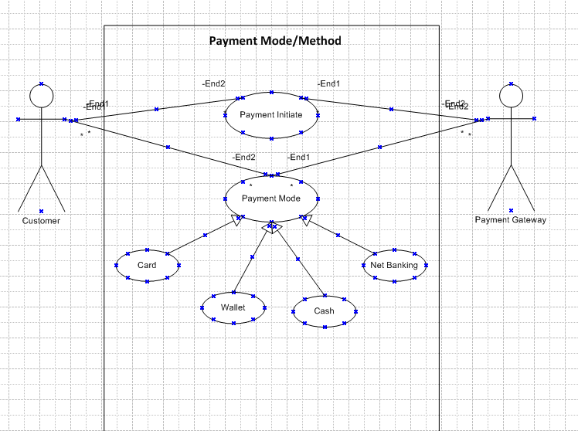
Q2. Derive Boundary Classes, Controller classes, Entity Classes. - 4 Marks
Answer 2:
Boundary Class: It handles the communication between the system and external actors. It places in Application Layer.
Ex. Login Page, Payment Page, Registration Form

Controller Class: It coordinates the flow between boundary and entity class. It acts a bridge or intermediator between boundary and entity class. It places in Business Logic Layer.
Ex. Payment Controller (handles transaction flow),

Entity Class: It represents code data and persist in storage. It places in Database Layer.
Ex. Customer, Order, Bank Account, Exam Candidate, Transaction.

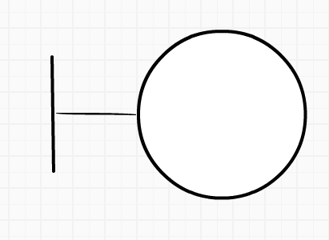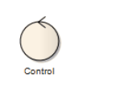

Q3. Place these classes on a three tier Architecture. - 4 Marks
Answer 3: Three Tier Architecture:

Application Layer – It handles user interface and input/output. It handles what user want to see. Application Layer place in Boundary Class. It can handle screens, pages, forms, etc.

Business Logic Layer – It contains all reusable components and logic that process data. It can be known as brain. Business Logic Layer place in Controller Class. It can be payment gateway, location, etc.

Database Layer- It stores and retrieve data from the database. It can be known as memory. Entity Layer place in Entity Class. It can be database, tables, stored procedures, etc.

Q4. Explain Domain Model for Customer making payment through Net Banking - 4 Marks
Answer 4: Domain Model: A domain model is a conceptual representation of the real world entities and their relationships in a system. It focuses on business concepts not technical details. We can call it as a Blueprint.
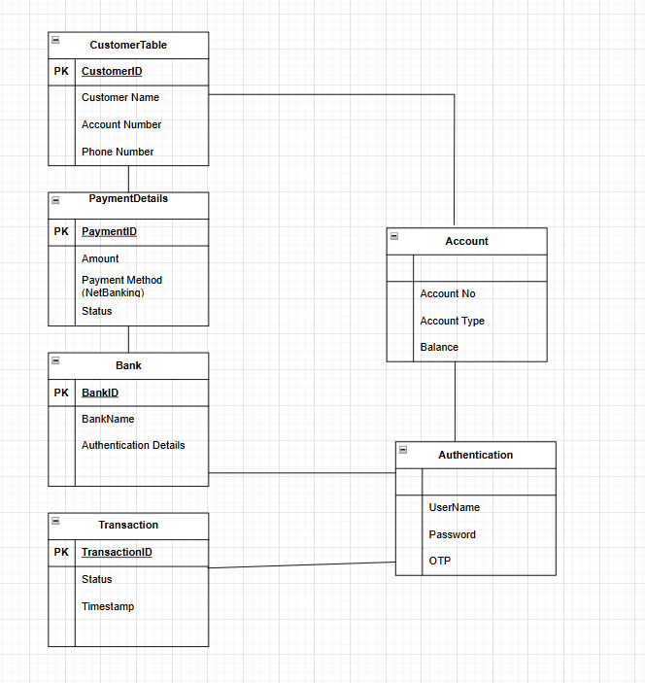

Q5. Draw a sequence diagram for payment done by Customer Net Banking - 4 Marks
Answer 5: Sequence Diagram: Sequence diagram show the interaction between objects and actors.
The sequence diagram shows the step-by-step interaction between Customer, Payment Page, Controller, Bank, and Transaction Record. It ensures clarity of how net banking payment flows in the system.

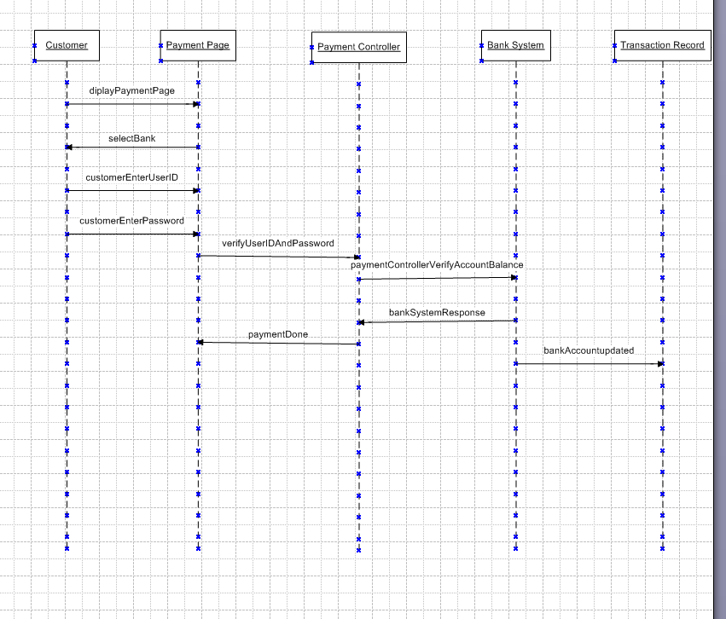

Q6. Explain Conceptual Model for this Case - 4 Marks
Answer 6:
Conceptual Model: A conceptual model is a high-level representation of system works. It shows the main entities (Customer, Payment Option and Transaction) and relationships. It does not include technical details. It as like a blueprint of concepts that explains what the system does, not how it does it.

Key Elements of Conceptual Model-
Customer: Customer is the one who initiates the payment.
Payment Option: Customer can select different payment options
Payment System: It manages all payment method
Transaction: The result of the payment process
Customer --> Payment System --> chooses Payment Option (Card/Wallet/Cash/Net Banking) --> Transaction recorded.

Q7. What is MVC architecture? Explain MVC rules to derive classes from use case diagram and guidelines to place classes in 3-tier architecture - 8 Marks
Answer 7:
MVC Architecture: MVC stands for Model View Controller. It is a design pattern which is used to separate concerns in software development. The main Purpose of MVC architecture is to make applications easier to manage, test, and scale.
Model: It represents data and business logic. It is mainly used for storing and processing information.
View: It represents User Interface (UI). It is mainly used for display data to the user.
Controller: It acts as a Bridge between Model and View. It handles Input and update the Model/View accordingly.

- Boundary Classes → View Layer
  - Derived from system boundaries in the use case diagram.
  - Example: Payment Page (UI boundary).
- Controller Classes → Business Logic Layer
  - Derived from actions or processes in the use case diagram.
  - Example: Payment Controller (handles payment process).
- Entity Classes → Data Layer
  - Derived from main entities in the use case diagram.
  - Example: Customer, Bank, Transaction.
👉 Rule of thumb:
- Boundary → View
- Controller → Logic
- Entity → Model

📌 Guidelines to Place Classes in 3-Tier Architecture
- Presentation Layer (UI)
  - Place Boundary Classes here.
  - Example: Payment Page, Wallet Page.
- Business Logic Layer
  - Place Controller Classes here.
  - Example: Payment Controller, Transaction Controller.
- Data Layer
  - Place Entity Classes here.
  - Example: Customer, Bank, Transaction.

Q8. Explain BA contributions in project (Waterfall Model – all Stages) – 8 Marks
Answer 8:
BA Contributions in Waterfall Model in various stages-
- Requirement Gathering: Business Analyst gather the requirement by using Elicitation Technique (interviews, workshops, surveys, observation, etc)
- Documenting Requirement: BA document all the requirements (BRD, FRD, Functional & Non-Functional Requirements)
- Modelling Requirement: BA prepare UML Diagrams (Use Cases, Activity Diagram, Sequence Diagram)
- Communication Requirement: BA communicate the requirements with Developers so that they can start working on.
- Track Requirement: BA also track the requirements by using RTM (Requirement Traceability Matrix) to ensure requirment
- Handle Change Request: BA handle the change request. BA evaluates the Impact of change and document the change and sign-off the changes
- Development Stage: BA also Clarify doubts in the terms of functionality and non-functionality. BA validate scope of the project
- User Acceptance Testing: BA also support in UAT testing. BA ensure that system is meeting the business expectations
- Deployment Stage: BA confirms with Stakeholder that the application meets Business needs.
- Maintenance Stage: BA handle Change Requests after deployment.

Q9. What is conflict management? Explain using Thomas – Kilmann technique – 6 Marks
Answer 9:
Conflict: Conflict means a disagreement or clash between two or more people, groups, or ideas. It happens when their interests, needs, or opinions are different and they cannot agree easily on one opinion.
Conflict Management is a technique to handle the disagreement between two or more people, group. This same kind of conflict can arise during the projects. A BA can resolve conflicts by listening, clarifying, staying neutral, and guiding stakeholders toward a solution that supports project objectives.
Five styles:
- Competing (win–lose)
- Collaborating (win–win)
- Compromising (middle ground)
- Avoiding (ignore conflict)
- Accommodating (give in)
Note: BA uses collaboration and compromise most often.
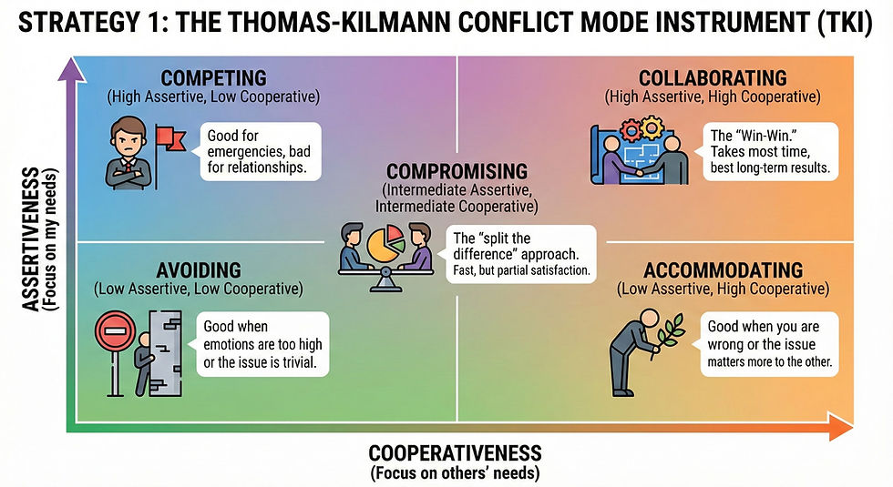

Q10. List down the reasons for project failure – 6 Marks
Answer 10:
Project failure means that a project does not achieve its objectives/motive within the agreed constraints of scope, time, cost, and quality.
- Doesn’t deliver what was promised (scope failure)
- Takes longer than planned (time failure)
- Costs more than budgeted (cost failure)
- Delivers poor quality output (quality failure).
There are few reason for project failure along with details-
A) Improper requirement gathering- If requirements are not collected correctly, the project may deliver the wrong solution. Missing or unclear requirements cause rework and delays.
B) Continuous change in requirement- Frequent changes without proper control lead to scope creep. This increases cost, effort, and confusion among the team.
C) Unrealistic timelines/expectation- Setting deadlines that are too tight or expectations that are too high results in poor quality and stressed teams.
D) Lack of user involvement- When end-users are not engaged during requirement gathering or testing, the final product may not meet their actual needs.
E) Lack of stakeholder involvement- Without active participation from stakeholders, decisions are delayed, priorities are unclear, and project direction suffers.
F) Improper Planning- Weak planning of resources, budget, and milestones leads to missed deadlines, cost overruns, and poor execution.

Q11. List the Challenges faced in projects for BA – 6 Marks
Answer 11: There are many challenges faced in Projects for BA. Few are listed below-

Obtaining sign-off on requirement- After gathering the requirement and document it, the BA needs formal approval (sign-off) from stakeholders (written). Sometimes stakeholders delay or hesitate to sign because they are unsure or keep asking for changes. Delay approval slows down the project and creates uncertainty.

Change Management-with respect to cost and timelines- If requirements change, it often affects the budget and schedule. The BA must explain the impact of changes clearly (Impact Analysis) and help stakeholders decide whether the change is worth the extra cost or time. Managing this balance is a big challenge.

Coordination between developers & testers- Developers build the system, and testers check if it works correctly. Miscommunication between them can cause defects or delays. The BA often acts as a bridge, clarifying the requirements so both sides understand the same thing.

Conducting meetings - A BA has to organize and lead meetings with different teams and stakeholders. Challenges include scheduling, keeping discussions focused, and ensuring everyone participates. Poorly managed meetings waste time and leave issues unresolved.

Driving client for UAT completion - UAT is when the client tests the system to confirm it meets their needs. Clients may delay testing due to lack of time or resources. The BA must push politely but firmly to ensure UAT is completed, otherwise the project cannot move to deployment.

People Management (coordinating with different people and different) - A BA interacts with many groups — business users, developers, testers, managers. Each has different priorities and communication styles. Managing these relationships and keeping everyone aligned is a constant challenge.

Q12. Write about Document Naming Standards – 4 Marks
Answer 12: Document Naming Standard should be followed in clear and consistent way. Naming convention should use standard format.
All documents will be named using some standards like [ProjectID] [Document Type] V [X] D[Y] . ext
Example: ProjectName_Business Requirement Document_V1_23-06-2026.docx

Q13. What are the Do’s and Don’ts of a Business analyst – 6 Marks
Answer 13:
Do’s of Business analyst: As a Business Analyst, we should follow few rules:
- Communicate Clearly- Always explain requirement in simple and easy language. Always acknowledge all the emails.
- Document Everything- Prepare proper documents (BRD, FRD, SRS, RTM) and keep them updated.
- Engage Stakeholder- It is BA’s responsibility to involve Stakeholder in the Project to project succession.
- Validate Requirement- Use the 3-4 elicitation techniques for requirement gathering and validate those requirements with User/Business needs. For any clarification, should consult with SME.
Don’ts of a Business Analyst: As a Business Analyst, we should not
- Never ever say NO to client.
- Never Assume requirements and as per BA, there is no scope for “By Default”
- Never ignore feedback and delay clarifications
- Never skip documentation, delay clarifications

Q14. Write the difference between packages and sub-systems – 4 Marks
Answer 14:
Packages | Sub-Systems
Packages are the collection of Components which are not reusable in nature. | Packages are the collection of Components which are reusable in nature.
Service/Application Development Based Companies work on Packages. | Product Development Based Companies work on Packages
Packages are small and focused | Sub-systems are broad and may contain many packages
Packages are Logical grouping of classes | Sub-systems are Larger functional unit

Q15. What is camel-casing and explain where it will be used- 6 Marks
Answer 15:
Camel Casing: Camel casing is a style of writing names where the first word starts with a lowercase letter, and each subsequent word begins with an uppercase letter. There are no spaces or underscores between words.
We use to write the naming of variables, methods or functions. Names can be read easily. These are used in many programming languages i.e. Java, Python (getEmpID()).
Example: customerName, customerAddress, employeeSalary, etc.

Q16. Illustrate Development server and what are the accesses does business analyst has? - 6 Marks
Answer 16:
Development Server: A Development Server is a special environment where developers build, test, and debug code before it goes to higher environments (like production). It is completely different from Product (Live) Server so that mistakes or incomplete features do not affect the actual users.
Developers always change the code in Development Server and the move the code to Production Server.

BA Access for Development Server: A BA usually has Limited or Read-Only to Development Server. BA can check logs, BA can test the data, BA can review the screens or workflows but not modify code. BA is more focused on clarification or requirement validation.

Q17. What is Data Mapping? 6 Marks
Answer 17:
Data Mapping: Data Mapping is the process of linking or matching data field from one system to another. It ensures that the flow of information correctly between different application, database or modules. It ensures that the data should flow smoothly among systems.
If data is not moving correctly, then data can be lost, mismatched or misinterpreted.

Q18. What is API. Explain how you would use API integration in the case of your application Date format is dd-mm-yyyy and it is accepting some data from Other Application from US whose Date Format is mm-dd-yyyy.
10 Marks
Answer 18:
API: API stands for Application Programming Interface. An API (Application Programming Interface) is a bridge that allows two different systems to communicate and exchange data. It defines how requests and responses should be structured so that both systems understand each other.

The Case – Date Format Mismatch/interchange
Our application accepts dates in dd-mm-yyyy (Indian Date Format) format (e.g., 23-06-2026).
The US application sends dates in mm-dd-yyyy format (US Date Format) (e.g., 06-23-2026).
If we directly transfer data, the meaning of the date will be wrong (23 June vs June 23).
Solution – API Integration with Transformation Logic
When the US application sends data through the API, a middleware or transformation layer will process the date.
The API integration will:
Receive the date in US format (mm-dd-yyyy).
Convert it into the required format (dd-mm-yyyy).
Save it correctly in our application database.
Example:
Input from US app: 06-23-2026
Middleware logic: Convert to 23-06-2026
Stored in our system: 23-06-2026

